AN

INTERNSHIP REPORT

on

BLOG WEBSITE

Submitted in partial fulfilment for the Award of Degree of

BACHELOR OF ENGINEERING

IN

ARTIFICIAL INTELLIGENCE AND DATA SCIENCE

BY

**Pallapuneedi Bhavya Sree (160121771085)**

**Pasunuri Kathyayini (160121771088)**

Deshamoni Sree Harsha (160121771100)

Katari Sanjeev Varma (160121771106)

Under the guidance of

N. Shiva Kumar,

Assistant Professor,

Department of IT



DEPARTMENT OF INFORMATION TECHNOLOGY CHAITANYA BHARATHI INSTITUTE OF TECHNOLOGY (A)

**(Affiliated to Osmania University; Accredited by NBA (AICTE) and NAAC (UGC), ISO Certified 9001:2015), KOKAPET (V), GANDIPET(M), HYDERABAD – 500 075**

**Website:** [**www.cbit.ac.in**](http://www.cbit.ac.in/)

2022-2023



CERTIFICATE

This is to certify that the project seminar report entitled “**Blog website**” submitted to **Chaitanya Bharathi Institute of Technology**, in partial fulfilment of the requirements for the award of degree of **B.E (**Artificial Intelligence and Data Science**)** during the academic year 2022-23 is a record of original work carried out by **Pasunuri Kathyayini(160121771088)**, **Pallapuneedi Bhavya Sree (160121771085), Deshamoni Sree Harsha (160121771100)** and **Katari Sanjeev Varma(160121771106)** during the period of study in the Department of IT, CBIT, Hyderabad.

|  |  |
| --- | --- |
| **Mentor** | **Head of the Department** |
| **Mentor Name** | **Dr. K. Radhika** |
| Designation | Professor, Dept. of IT, |
| CBIT, Hyderabad. | CBIT, Hyderabad. |

ABSTRACT

A blogsite is a type of website that focuses on written content, typically in the form of blog posts or articles. Blogging has become increasingly popular in recent years as a means of sharing information, opinions, and personal experiences with a wider audience. Blogsites can cover a wide range of topics, from personal anecdotes and lifestyle advice to news and current events, business and finance, health and wellness, travel, and much more. They offer a platform for individuals and organizations to express themselves, engage with readers, and build a community around their interests. Here, we aim to create such a blogsite where people can share their experiences, thoughts and opinions in a safe and supportive environment while building a honest, responsible and knowledgeable community. The website will contain a homepage with all blogs written by it’s users for everyone to read and a write page where the user has to register/login before he/she can write their own blogs. The user can even edit or delete their blogs once submitted. This website is developed using a MERN stack which stands for MongoDB — document database, Express(.js) — Node.js web framework, React(.js) — a client-side JavaScript framework, Node(.js) — the premier JavaScript web server. These are the four technologies that make up the web development stack. We also use HTML, CSS for developing frontend part of the website. This website serves as a user-friendly and interactive platform for indirect exchange of information while engaging with a like-minded community.

|  |  |  |
| --- | --- | --- |
| **TABLE OF CONTENTS** | | |
| **Title** | **Page No** |
| Abstract | iii |
| List of figures | v |
| 1. **INTRODUCTION** |  |
| 1.1 Overview |  |
| 1.2 Applications |  |
| 1.3 Problem Definition |  |
| 1.4 Aim of the Project |  |
| 1. **SYSTEM REQUIREMENT SPECIFICATIONS** |  |
| 2.1 Functional Requirements |  |
| 2.2 Non-Functional Requirements |  |
| 2.3 Software Requirements |  |
| * 1. Hardware Requirements |  |
| 1. **METHODOLOGY/PROPOSED SYSTEM** |  |
| 3.1 System Architecture/System Design/Algorithms |  |
| 1. **RESULTS** |  |
| 1. **CONCLUSION** |  |
| BIBLIOGRAPHY |  |

LIST OF FIGURES

|  |  |
| --- | --- |
| **Name of Figure** | **Page no.** |

1. **INTRODUCTION**
   1. **Overview:**

A blog website is a platform that provides informative and engaging content on various topics, such as lifestyle, health and wellness, technology, travel, education, and more. It serves as a one-stop-shop for individuals seeking valuable insights and knowledge on different subjects.

A typical blog website usually features a user-friendly interface that makes it easy for visitors to navigate and find the content they are interested in.

Most blog websites are built with modern and clean aesthetics, making them visually appealing and easy to use. They often provide a range of features, such as search functions, comment sections, social media sharing buttons, and email newsletter signups.

The writers and editors who create content for blog websites are typically passionate and knowledgeable about the topics they cover. They strive to deliver high-quality, well-researched articles that are both informative and entertaining.

Overall, blog websites serve as a reliable source of information and a platform for open communication and interaction between writers and readers. They provide a space for individuals to learn, share, and engage with others who share similar interests and passions.

* 1. **Applications:**

Blog websites have a wide range of applications and can be used for various purposes. Here are a few examples:

**Personal blogging:** Many individuals use blog websites to share their thoughts, experiences, and stories with the world. Personal blogging allows people to express themselves and connect with others who share similar interests and experiences.

**Business and marketing:** Blogging can also be used as a marketing tool for businesses to promote their products or services. By creating informative and engaging content, businesses can attract potential customers and build brand awareness.

**Education:** Blog websites can be used as a platform for sharing educational content. Many educators use blog websites to provide learning materials, resources, and insights to students and the wider community.

**Journalism and news:** Many news outlets and journalists use blog websites to provide up-to-date news and insights on current events.

**Social and cultural movements:** Blog websites can also be used as a platform for social and cultural movements to share their message and raise awareness about important issues.

* 1. **Problem Definition:**

Many individuals are seeking a platform to express themselves and share their knowledge and experiences with others. However, they lack a user-friendly, visually appealing, and reliable platform to do so. As a result, there is a need for a high-quality blog website that provides a space for writers to create and publish engaging and informative content, while also fostering a community of readers who can interact and engage with the writers and each other. This blog website must be designed with features that encourage user participation, provide a safe and respectful environment for discussions and interactions, and ensure the accuracy and quality of the content. Many online platforms lack diversity and inclusivity, resulting in a limited range of perspectives and experiences being shared. As a result, there is a need for a blog website that is specifically designed to provide a space for all groups to share their stories and raise their voices.

**1.4 Aim of the Project:**

The aim of this project is to develop a blog website that serves as a valuable platform for sharing knowledge and experiences, fostering a community of readers and writers, and ensuring the accuracy and quality of the content while promoting a safe and respectful environment for all participants and to promote diversity, inclusivity and let all kinds of people share their thoughts, views, and experiences.

**2. SYSTEM REQUIREMENT SPECIFICATION**

**2.1 Functional Requirements:**

Functional Requirements are requirements that define specific behavior or function of the system.

* **User authentication:** The blog site must allow users to register, log in and log out securely.
* **Post creation and management:** The site must allow users to create, edit and delete blog posts with appropriate metadata such as date, author, categories, etc.
* **User profile management:** The site must allow users to manage their profiles, update their personal information, and view their blog posts and comments.
  1. **Non-Functional Requirements**:
* **Performance:** The website should load quickly and should be able to handle a large number of concurrent users without slowing down or crashing.
* **Availability:** The website should be available 24/7, with minimal downtime for maintenance or upgrades.
* **Security:** The website should be secure, with proper authentication, authorization, and encryption in place to protect user data and prevent unauthorized access.
* **Scalability:** The website should be able to handle increasing traffic and data volume without compromising performance or availability.
* **Usability:** The website should be easy to use and navigate, with a clear and intuitive user interface and responsive design that adapts to different devices.
* **Accessibility:** The website should be accessible to users with disabilities, with features such as screen reader compatibility, keyboard navigation, and alt tags for images.
* **Compatibility:** The website should be compatible with a wide range of web browsers and operating systems and should support different screen sizes and resolutions.
* **Maintainability:** The website should be easy to maintain and update, with clear documentation and a modular architecture that allows for easy customization and expansion.
* **Reliability:** The website should be reliable, with minimal errors or bugs, and a robust backup and recovery system in place in case of data loss or system failure.
* **Legal compliance:** The website should comply with relevant laws and regulations, such as data privacy and copyright laws, and should have proper terms of use and privacy policies.
  1. **Software Requirements:**

Web pages combine to form a website. A website is a collection of different web pages. We use specific coding to develop each page. So, there are three major components of a web page. Frontend, Backend and a server.

* *Operating System:*Windows
* *Text Editor/IDE:*Visual Studio Code
* *Programming Languages:* HTML, CSS, JavaScript
* *Front-End Frameworks:*ReactJS
* *Back-End Frameworks:* Express.js
* *JavaScript web server:*Node.js,
* *Application programming interface (API):* Post man
* *Database:*MongoDB
* **Visual Studio Code**: Visual Studio Code also commonly referred to as **VS Code**, is a source-code editor made by Microsoft, for Windows, Linux and macOS. Features include support for debugging, syntax highlighting, intelligent code completion, snippets, code refactoring, and embedded Git.  Users can change the theme, keyboard shortcuts, preferences, and install extensions add additional functionality.
* **Hypertext Markup Language:** HTML is the standard markup language for creating Web pages. HTML describes the structure of a Web page. HTML consists of a series of elements. HTML elements tell the browser how to display the content.
* **CSS:** CSS (Cascading Style Sheets) is a stylesheet language used to describe the presentation of a document written in HTML or XML. It is used to separate the presentation of a document from its structure and content. With CSS, you can control the layout, colours, fonts, and other visual elements of a web page. It allows you to create consistent and visually appealing designs across multiple web pages and devices. CSS can be applied to a single HTML element, multiple elements, or even an entire web page. It is a powerful tool for web developers and designers, as it allows them to create visually stunning and responsive websites with minimal effort.
* **React JS:** React is a declarative, efficient, and flexible JavaScript library for building user interfaces. ReactJS is an open-source, component-based front-end library responsible only for the view layer of the application. React is used to create modular user interfaces. It promotes the development of reusable UI components that display dynamic data. A React application is made of multiple components, each responsible for rendering a small, reusable piece of HTML. Components can be nested within other components to allow complex applications to be built out of simple building blocks.
* **Nodejs:** Node.js is an open-source, cross-platform JavaScript runtime environment and library for running web applications outside the client's browser.Node.js can generate dynamic page content.Node.js can create, open, read, write, delete, and close files on the server.Node.js can collect form data.Node.js can add, delete, modify data in your database.Node.js files contain tasks that will be executed on certain events. A typical event is someone trying to access a port on the server.Node.js files must be initiated on the server before having any effect.Node.js files have extension ".js"
* **Express.js:** Express.js is a popular and widely used web framework for Node.js. It provides a simple, minimalistic, and flexible approach to building web applications and APIs, allowing developers to create powerful and scalable server-side applications. Express.js is built on top of Node.js and provides several features such as routing, middleware, template engines, error handling, HTTP methods. Express.js provides a simple and powerful framework for building web applications and APIs with Node.js, making it a popular choice among developers.
* **MongoDB:** MongoDB Atlas document model enables developers to store data as JSON-like objects that resemble objects in application code. With MongoDB Atlas, use the tools and languages that you prefer. Manage your clusters with MongoDB CLI for Atlas, or IaC tools like Terraform or CloudFormation.
* **Postman:** Postman is an API development tool that allows developers to design, test, and document APIs easily. Postman provides a user-friendly interface that simplifies the process of working with APIs, and supports a wide range of HTTP request methods and response types. With Postman, developers can create and manage API requests and collections, organize requests into folders, and share them with other team members. The tool also supports automated testing, allowing developers to write test scripts to validate API responses and ensure that the API behaves as expected.

**2.4 Hardware Requirements:**

* *Processor:*Intel core i5
* *RAM:*8.0 GB
* *Hard Disk:*Minimum 20 GB free disk space
* *Internet Connection:*Required for accessing the website and its resources.

**3. METHODOLOGY/ PROPOSED SYSTEM**

The whole code is divided into two parts: the client side and the api.

The client section is installed with required react libraries and contains code for all the pages and components necessary for the website.

The api section is installed with express, mongoose and other required libraries and frameworks. It contains files linking to the mongodb database and codes written for essential backend connections and schemas

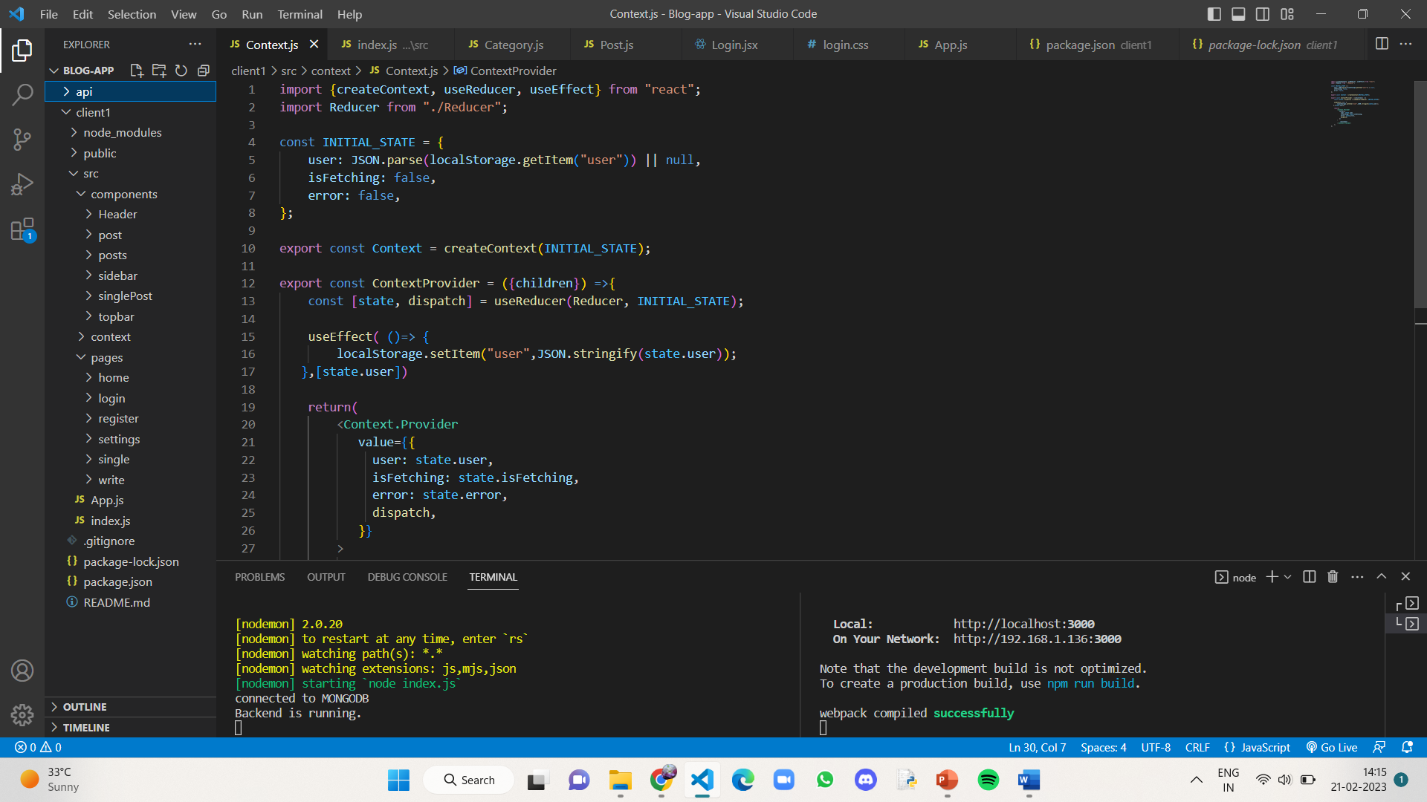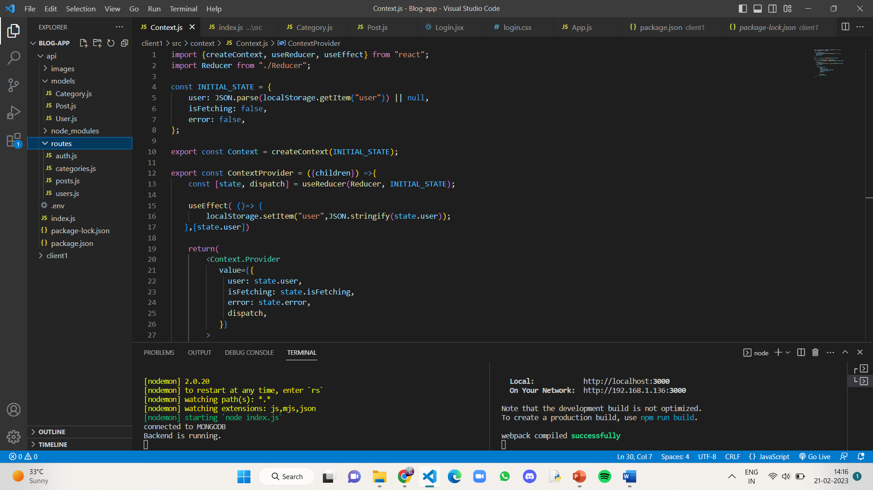

**Fig.1.1,1.2 file hierarchy in api and client**

Every component in client contains a .jsx file for the visual and functionality, a .css file for the style.

Header file creates a header for the website which will be showing the title with an image.

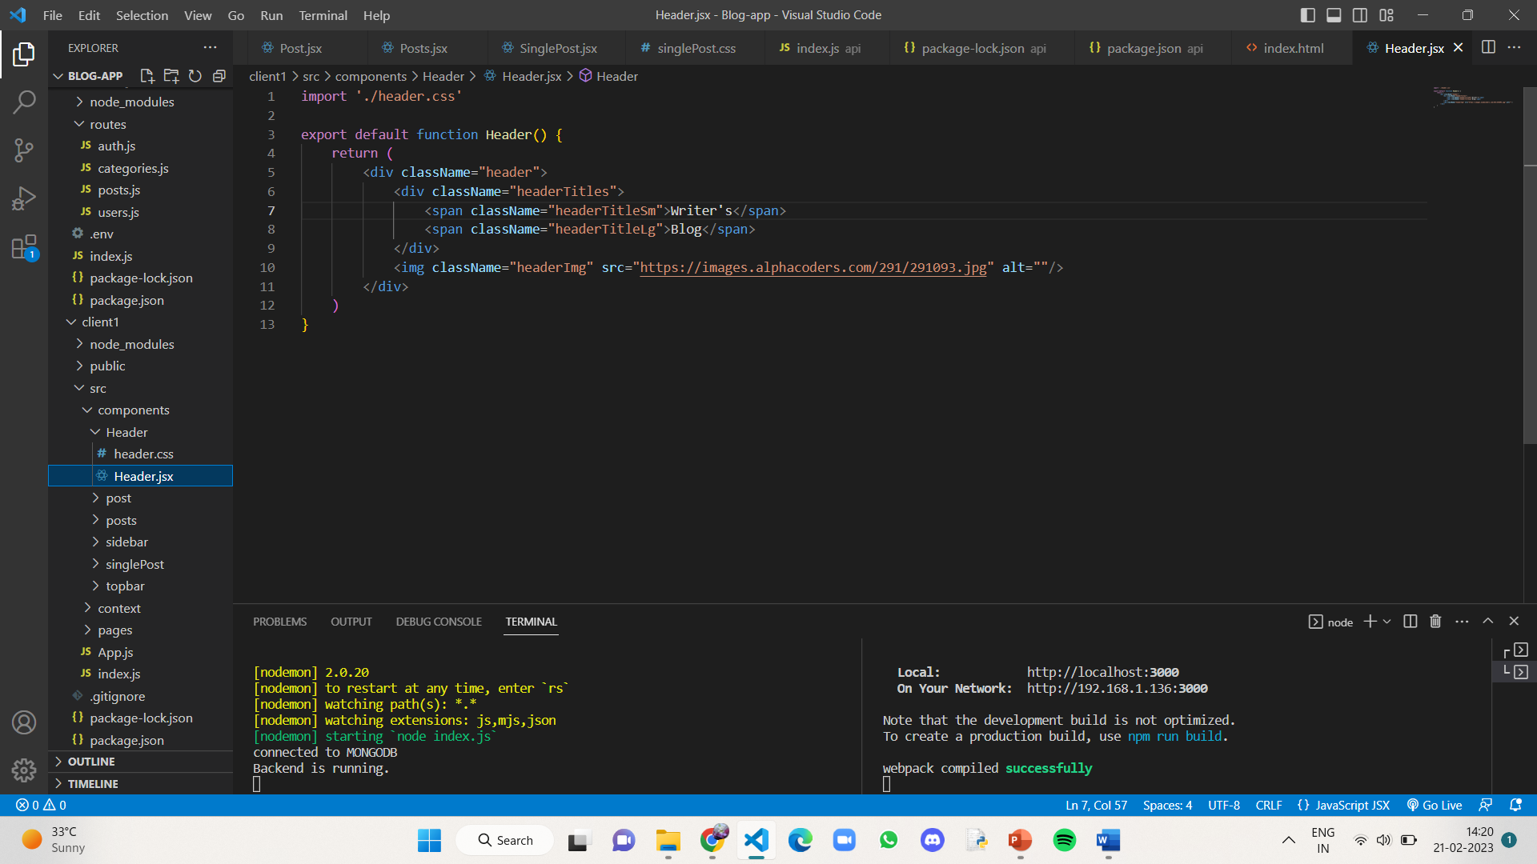

**Fig.2 Header.jsx**

The Post.jsx file contains the contents of a single post being displayed on the homepage, i.e, the title, author name, date and a part of the blog article. When clicked on the title, you will be directed to the full post.

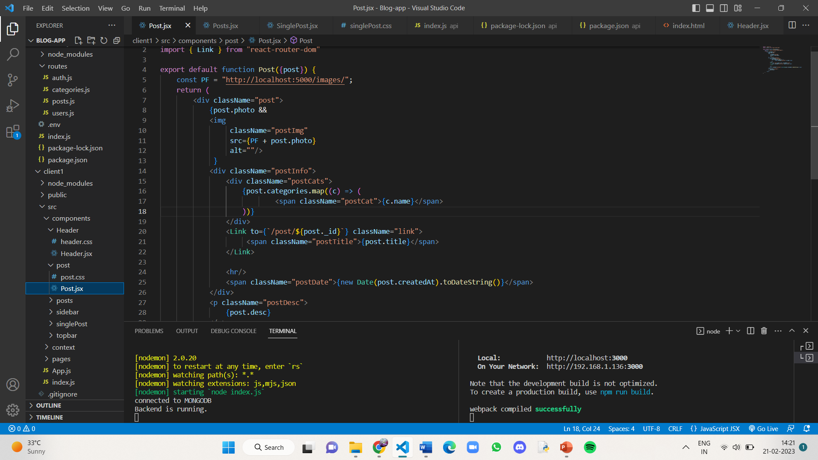

**Fig.3 Post.jsx**

The Sidebar.jsx file contains a bar that sits at the side on every page which has the description of website and categories available.

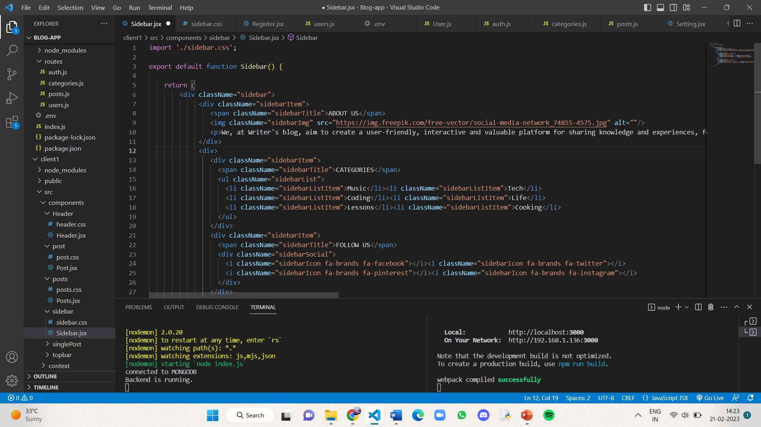

**Fig.4 Sidebar.jsx**

The Posts.jsx contains the layout of how all blogs are displayed on the homepage of the website.

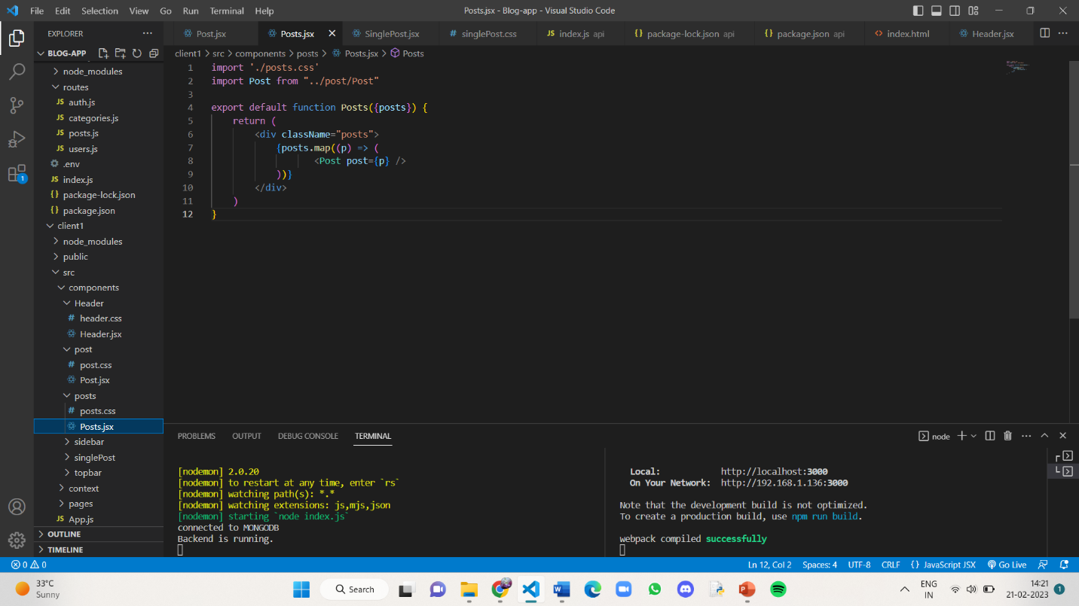

**Fig.5 Posts.jsx**

The SinglePost.jsx contains the page that shows up when clicked on a blog and also gives the options of updating and deleting it for the user who wrote that particular blog.

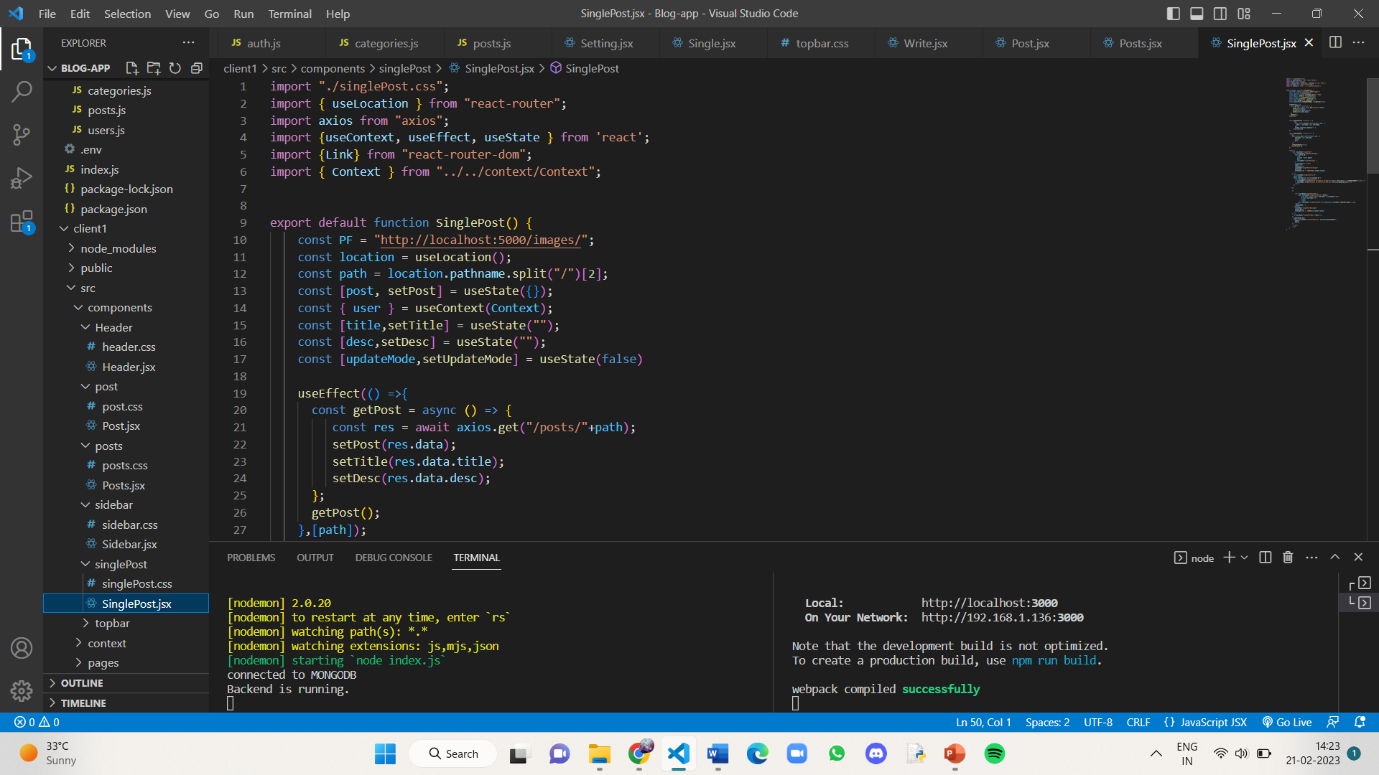

**Fig.6 SinglePost.jsx**

The Home.jsx contains how header, posts and sidebar are arranged on the homepage.

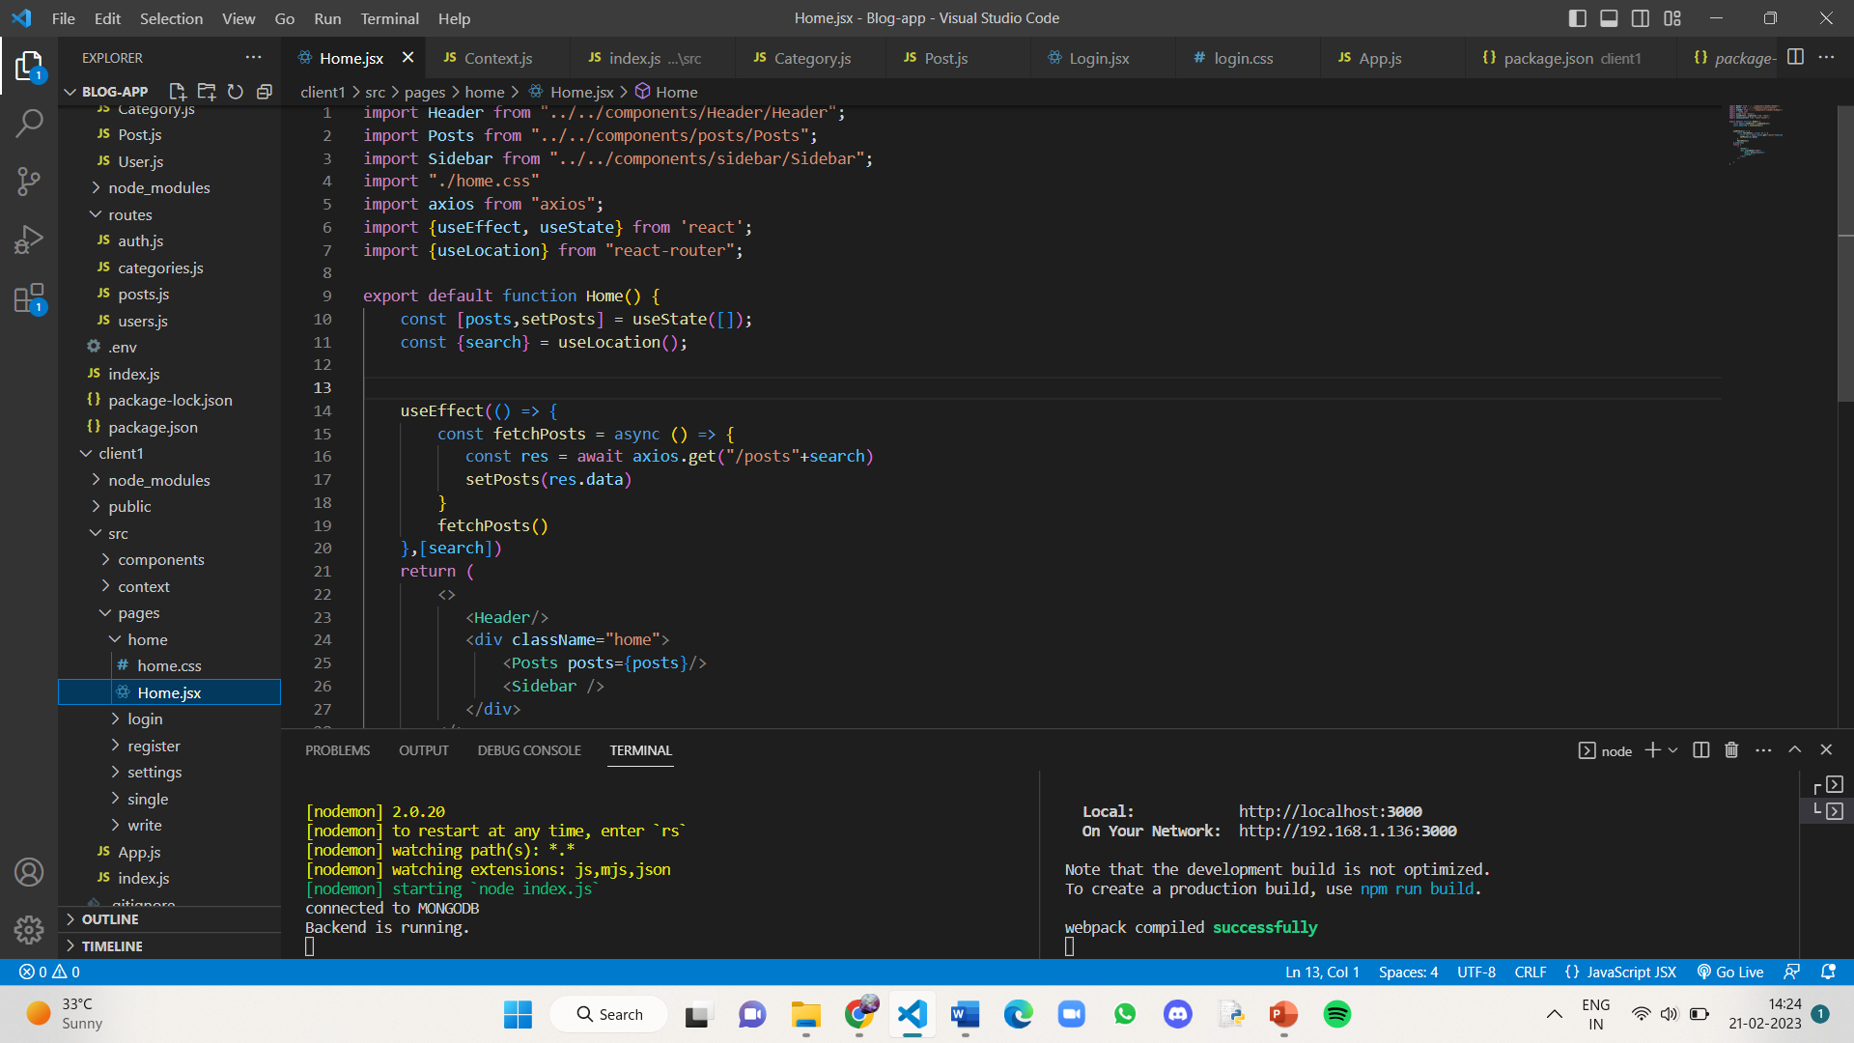

**Fig.7 Home.jsx**

Coming to the pages of the website, it contains a homepage, login, register, write, settings and a singlepost page. All these are shown below.

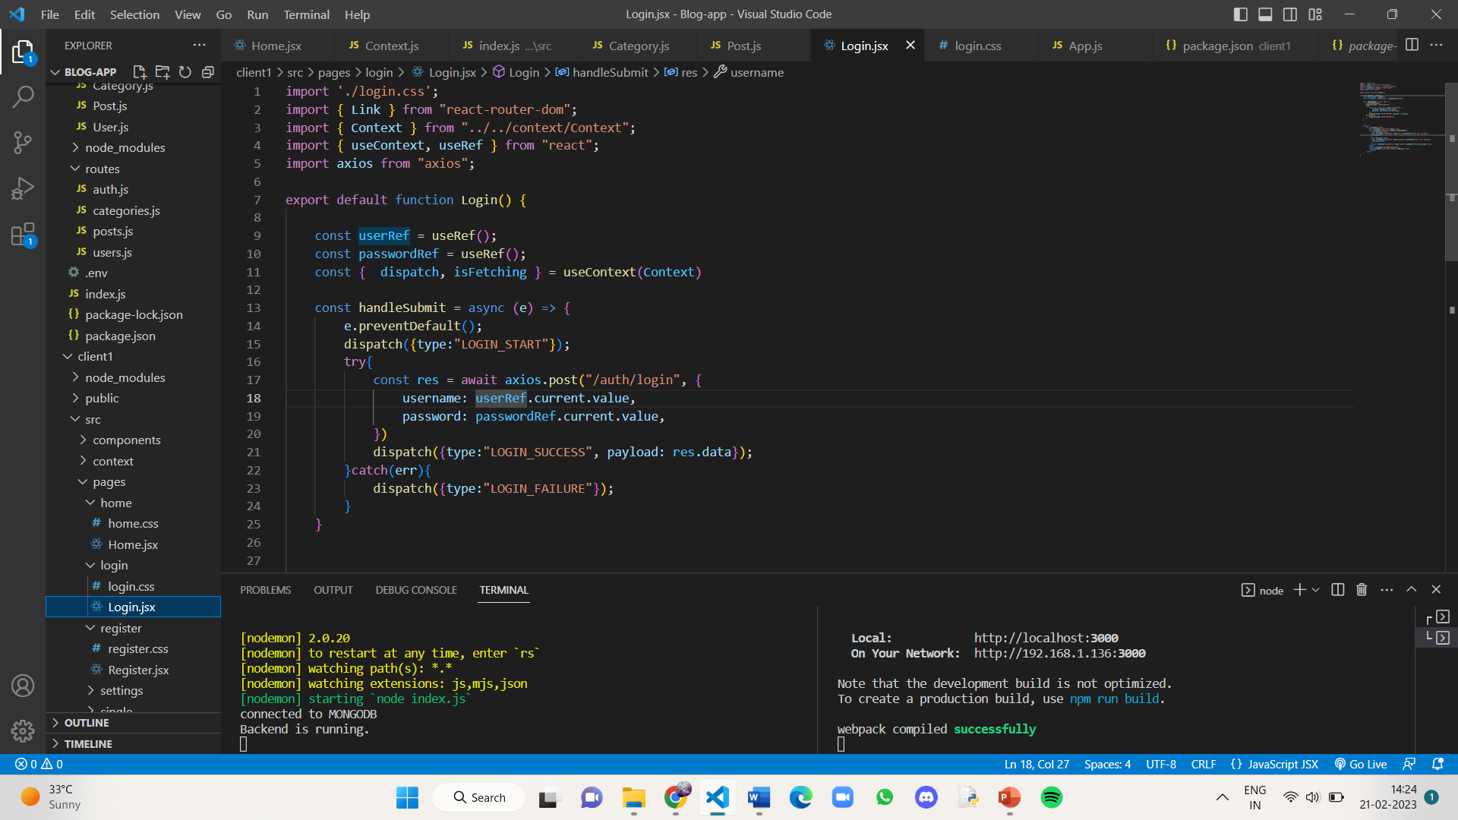

**Fig.8 Login.jsx**

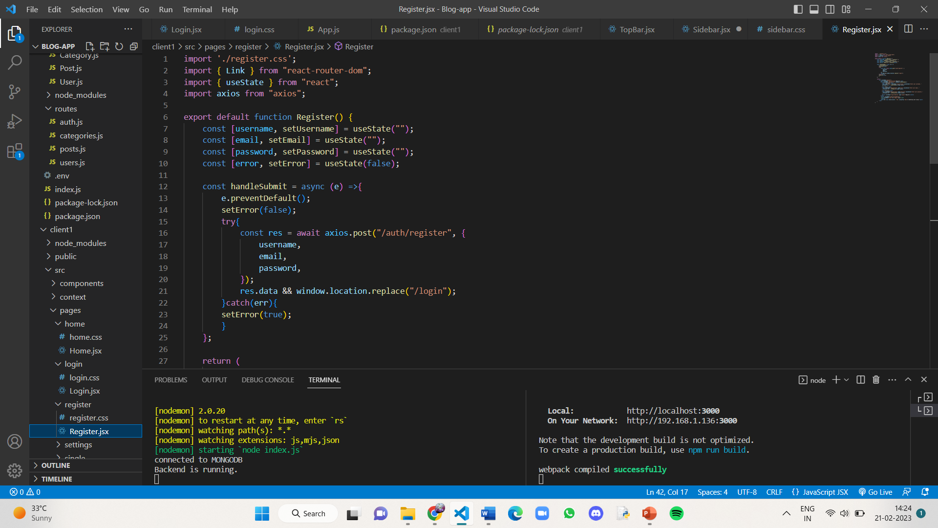

**Fig.9 Register.jsx**

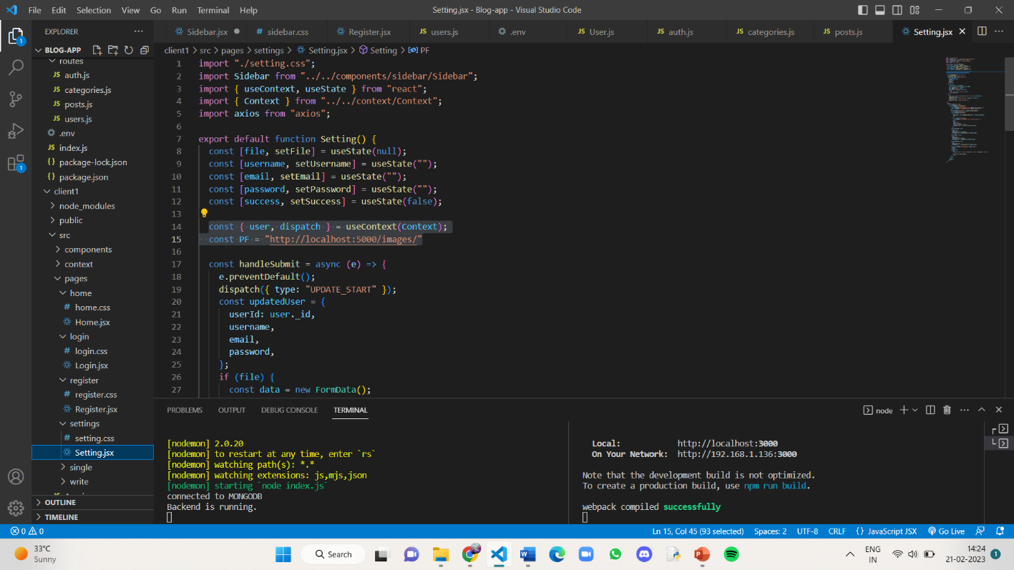

**Fig.10 Setting.jsx**

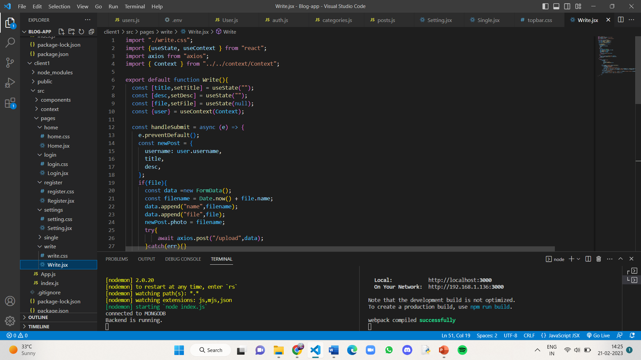

**Fig.11 Write.jsx**

In the api folder, the mongodb database’s url is written in a .env file and used in index.js file to give the connection.

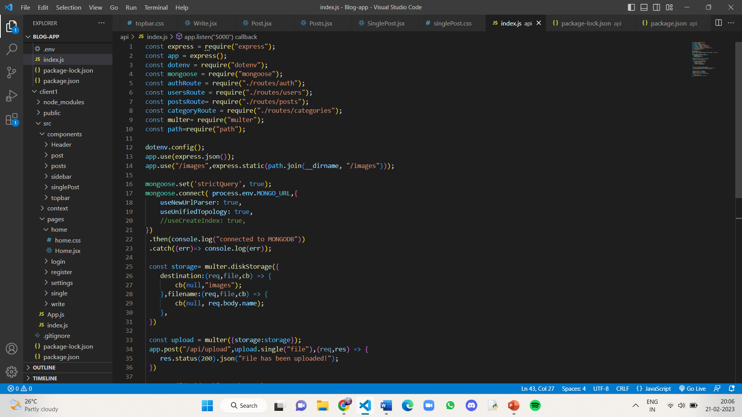

**Fig.12 index.js in api**

Database schemas are written in Category.js, Post.js, User.js which have defintions of data values each of them take.

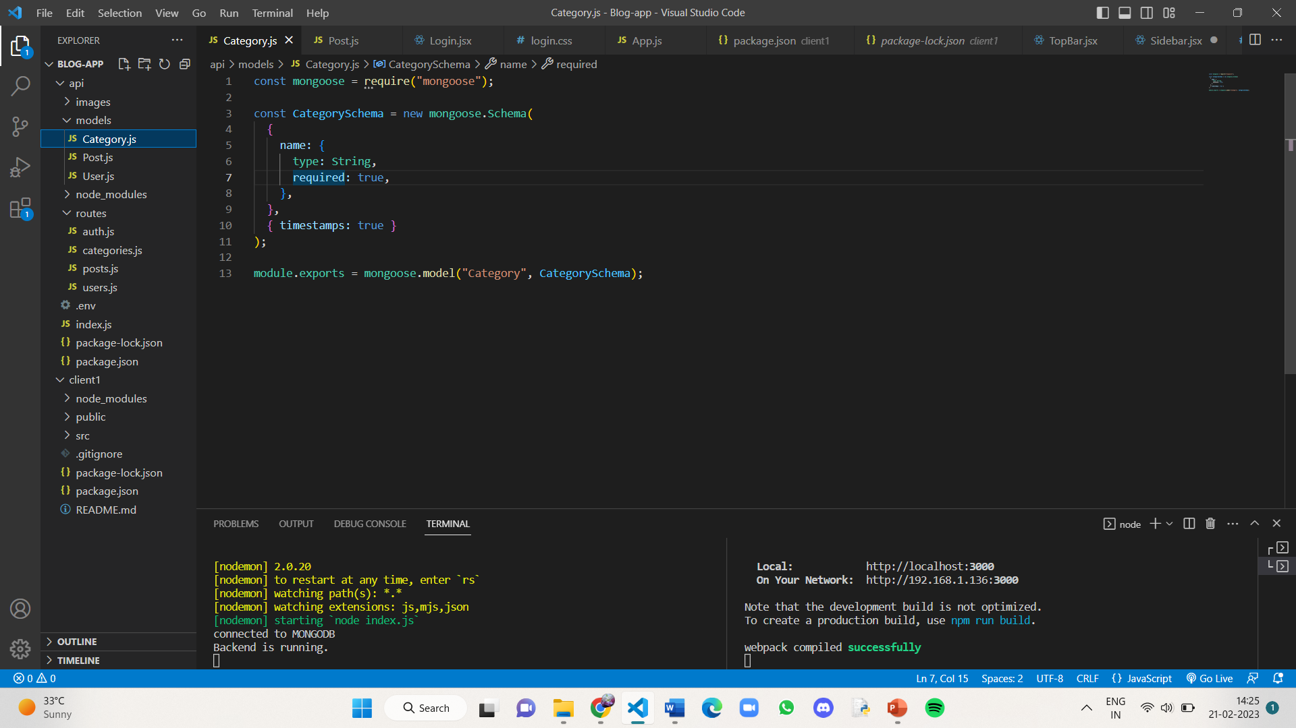

**Fig.13 Category.js**

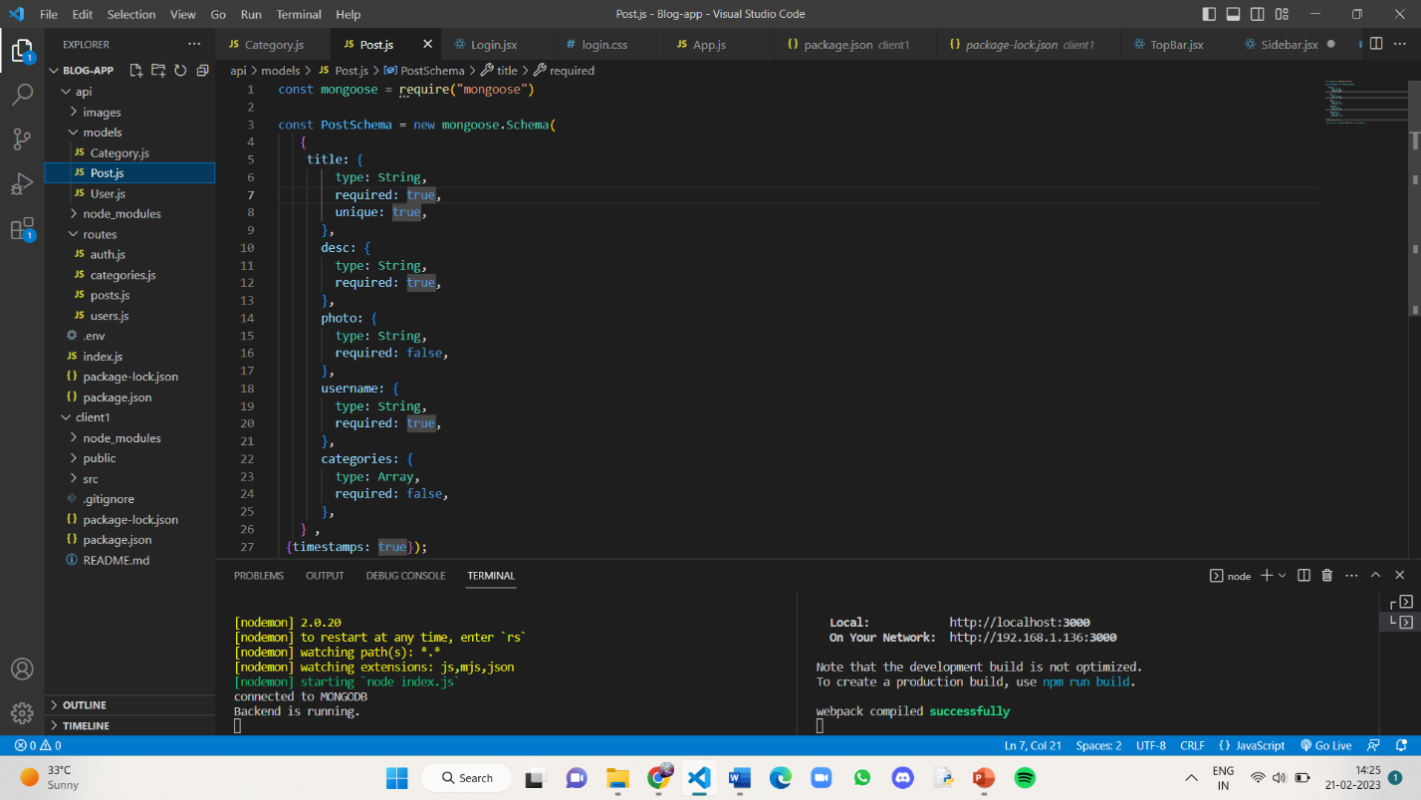

**Fig.14 Post.js**

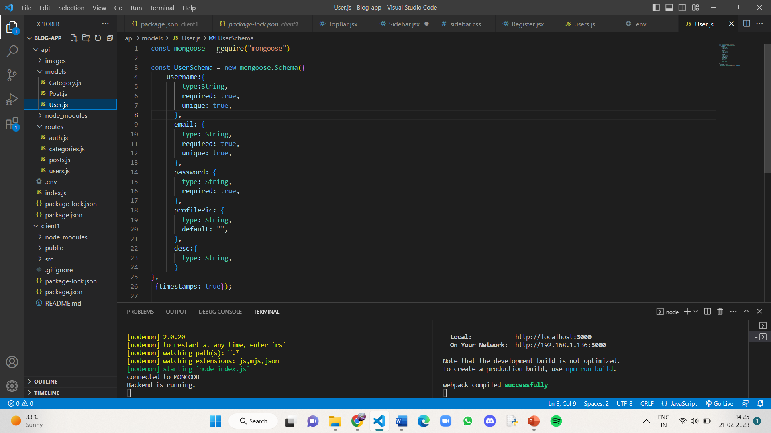

**Fig.15 User.js**

The routes folder contains files auth.js,categories.js,posts.js,users.js

The auth.js file contains the code on what should happen when a user registers and when a user logins to the website.

The posts.js file contains the code on how to create,delete,update a post and how to display one and all the posts on the website.

The users.js file contains the code on how to update, delete and display the details of a user.

All the codes in the above mentioned files are shown in the following page.

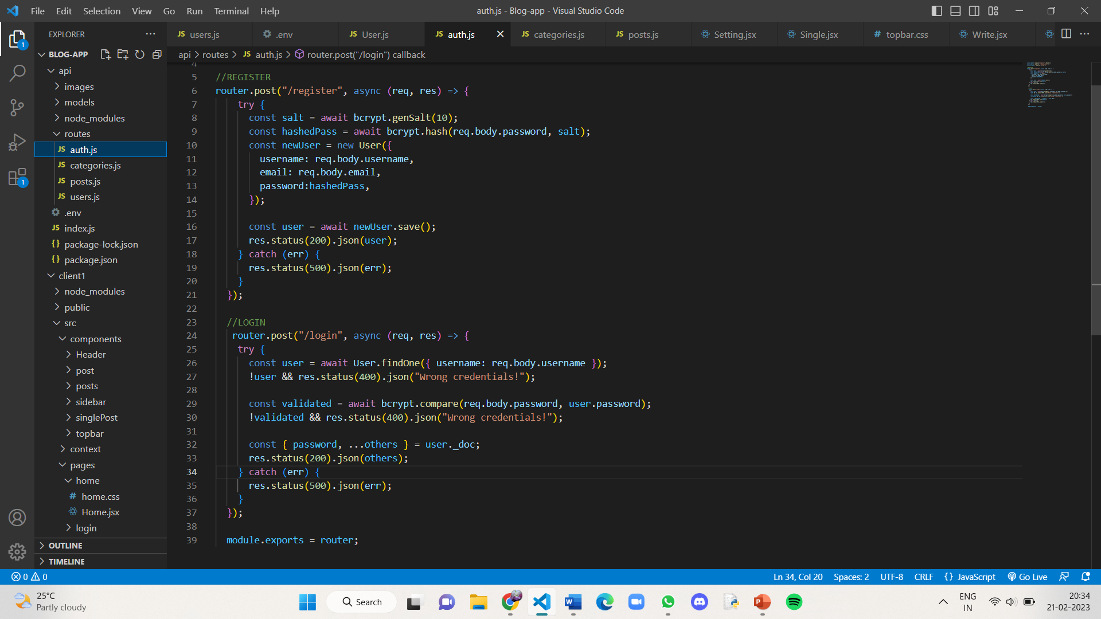

**Fig.16 auth.js**

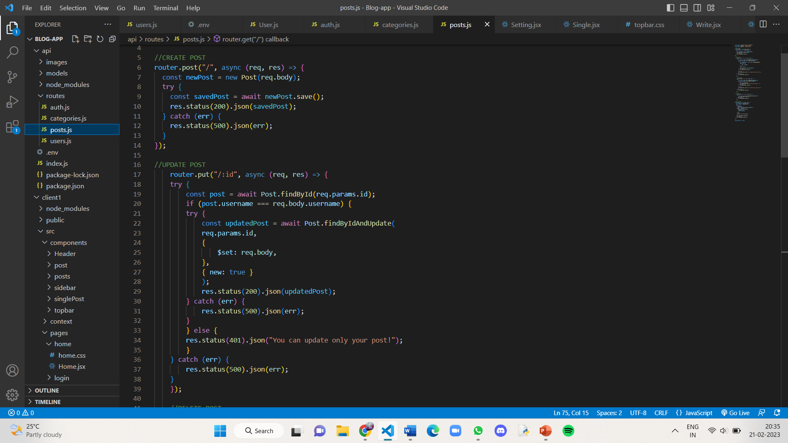

**Fig.17 posts.js**

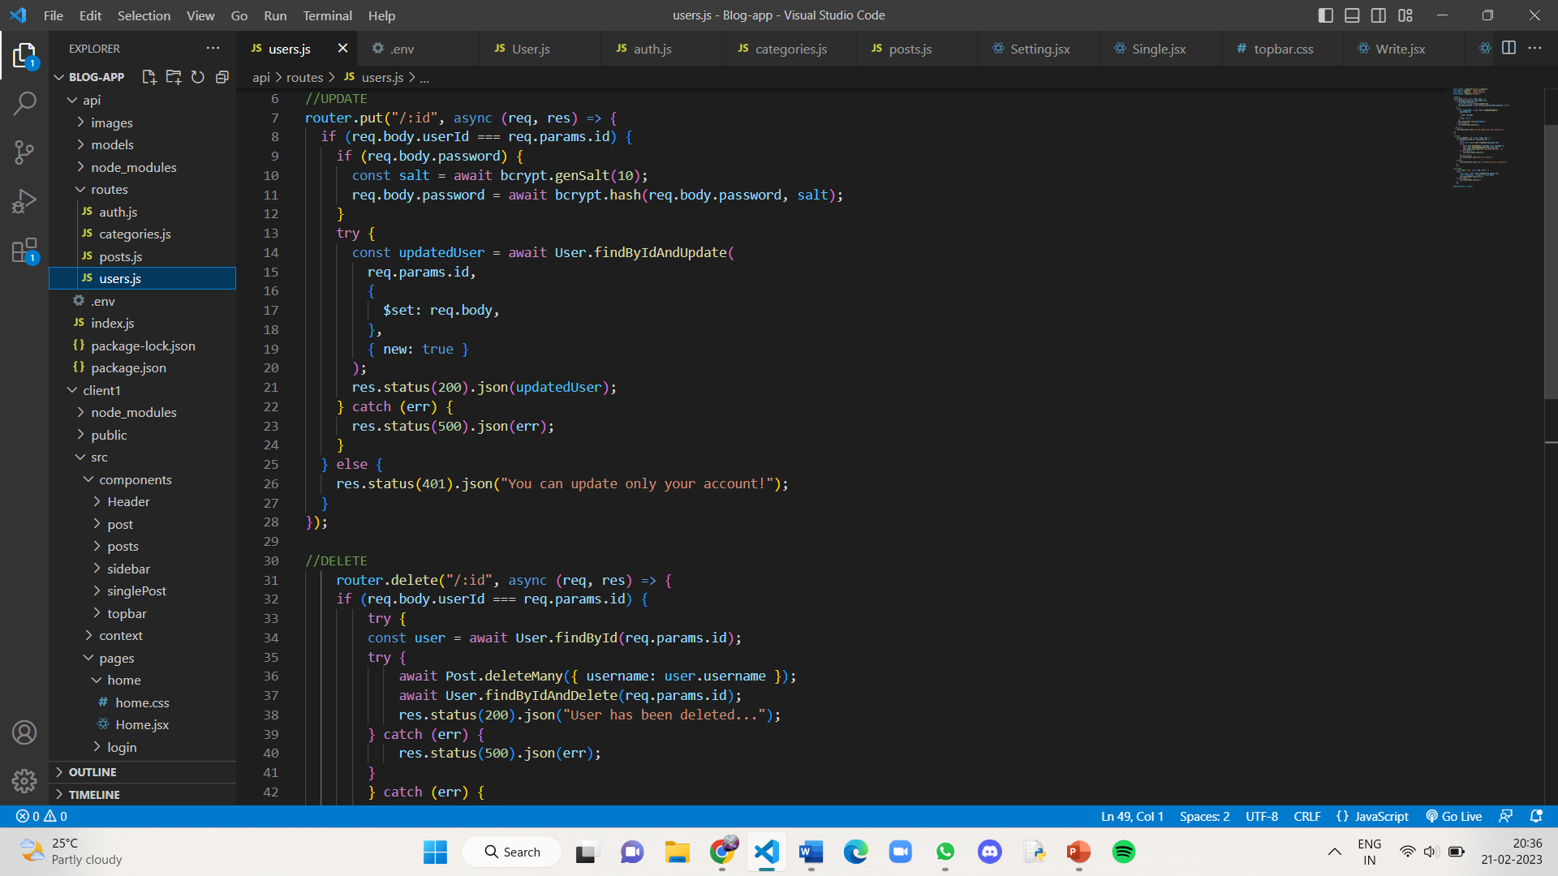

**Fig.18 users.js**

The App.js file in client folder contains the pages that should be displayed when a certain path is given in the url and switching between the pages are done according to the paths specified.

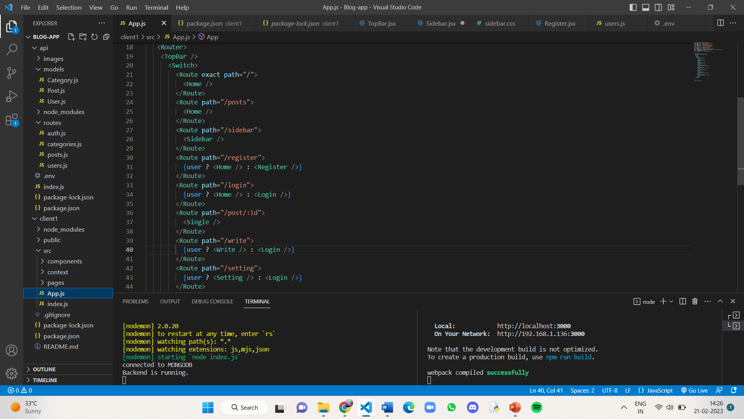

**Fig.19 App.js in client**

**5. RESULTS**

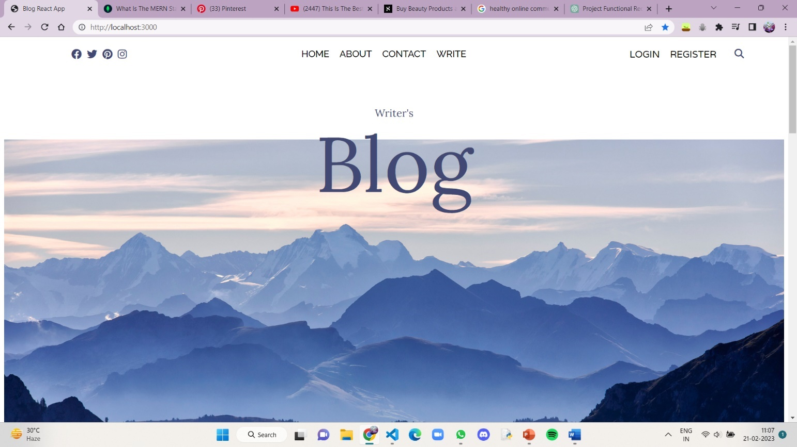The Homepage of the Blogsite:

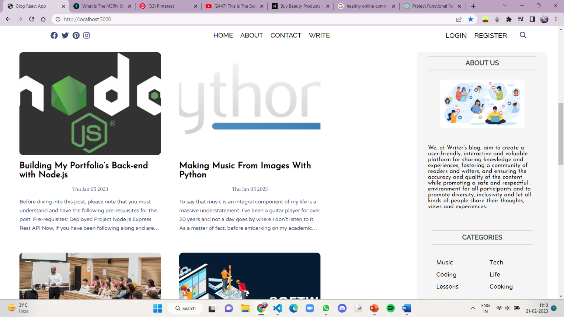

**Fig.20.1,20.2 Homepage**

The Register and Login pages of the website:

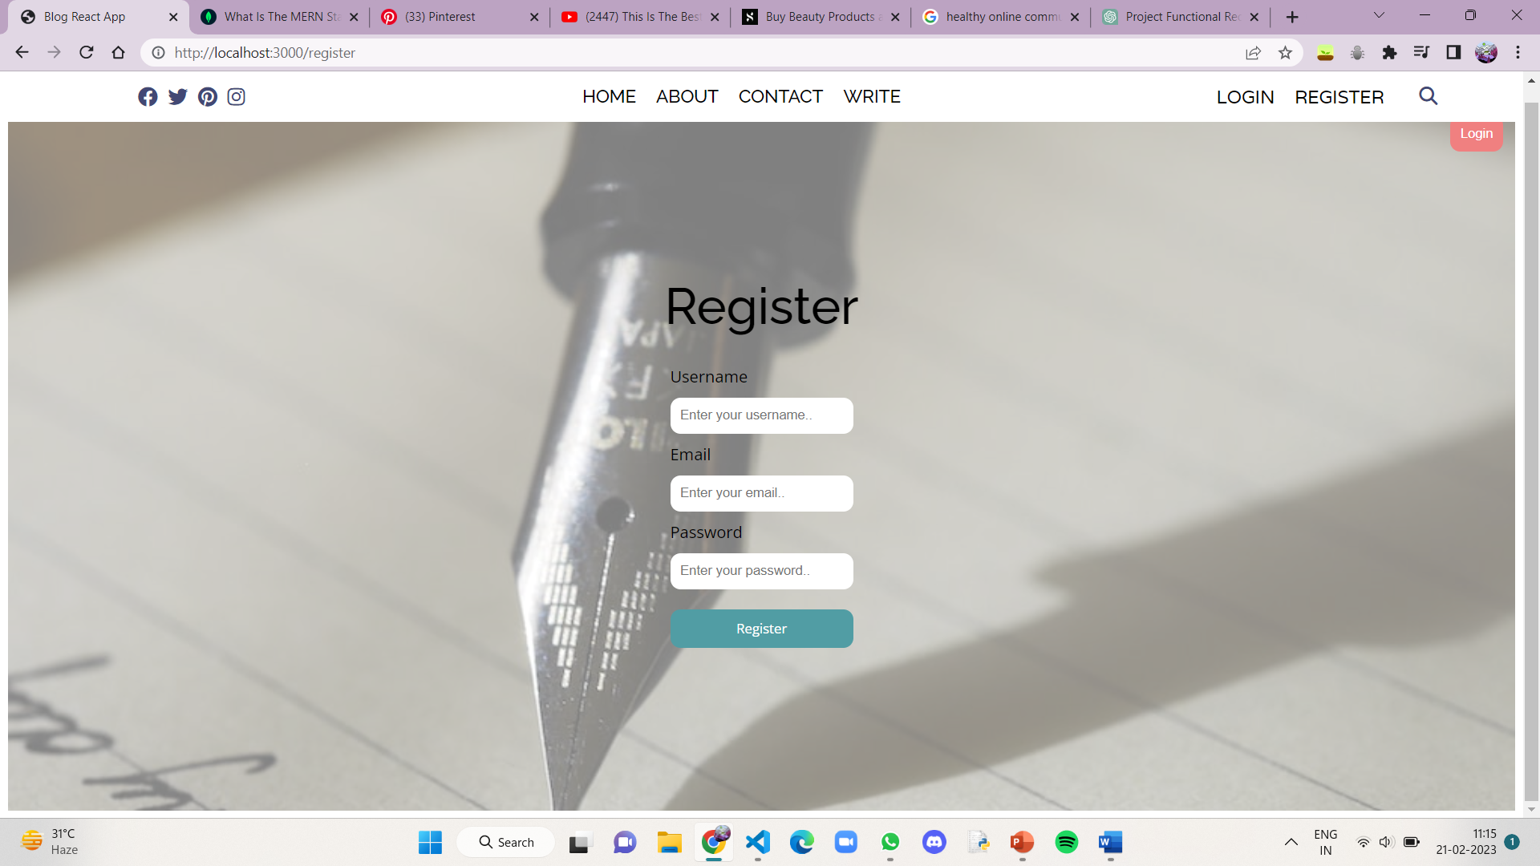

**Fig.21 Register page**

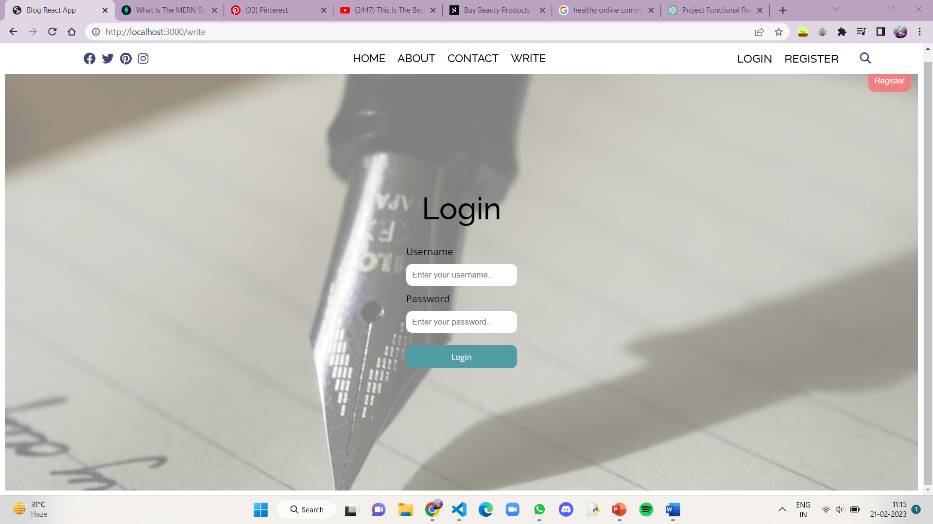

**Fig.22 Login page**

The Write page of the blogsite:

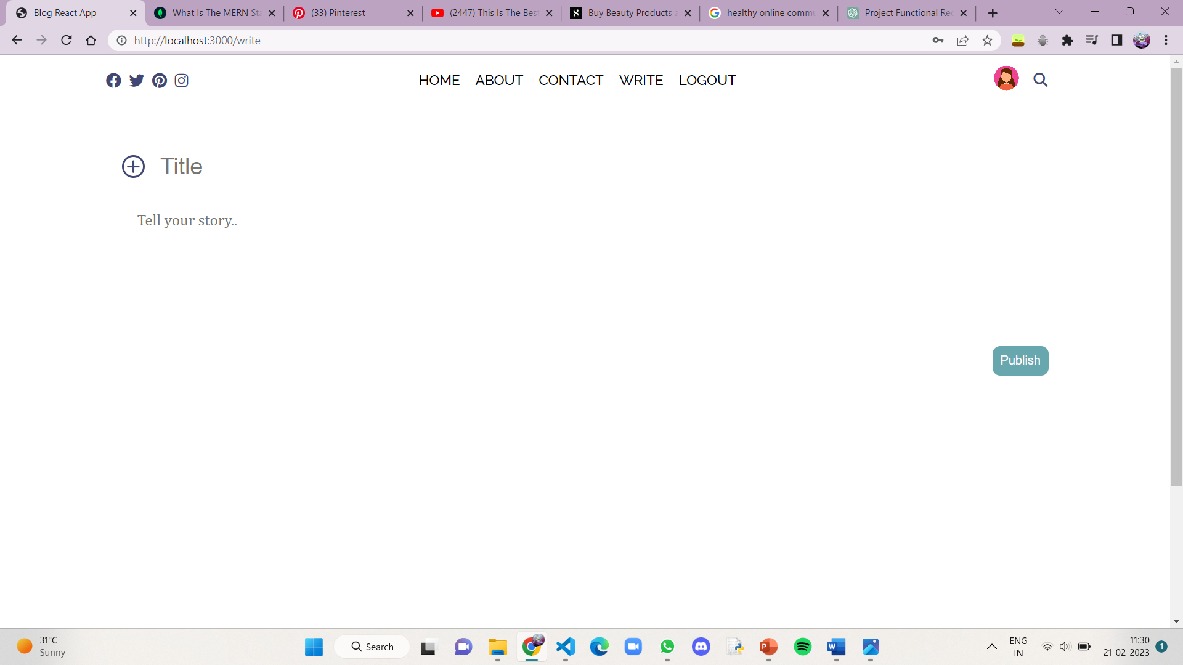

**Fig.23 Write page**

The Post page of the blogsite (This is how a single post looks when you click on it’s title from the homepage):

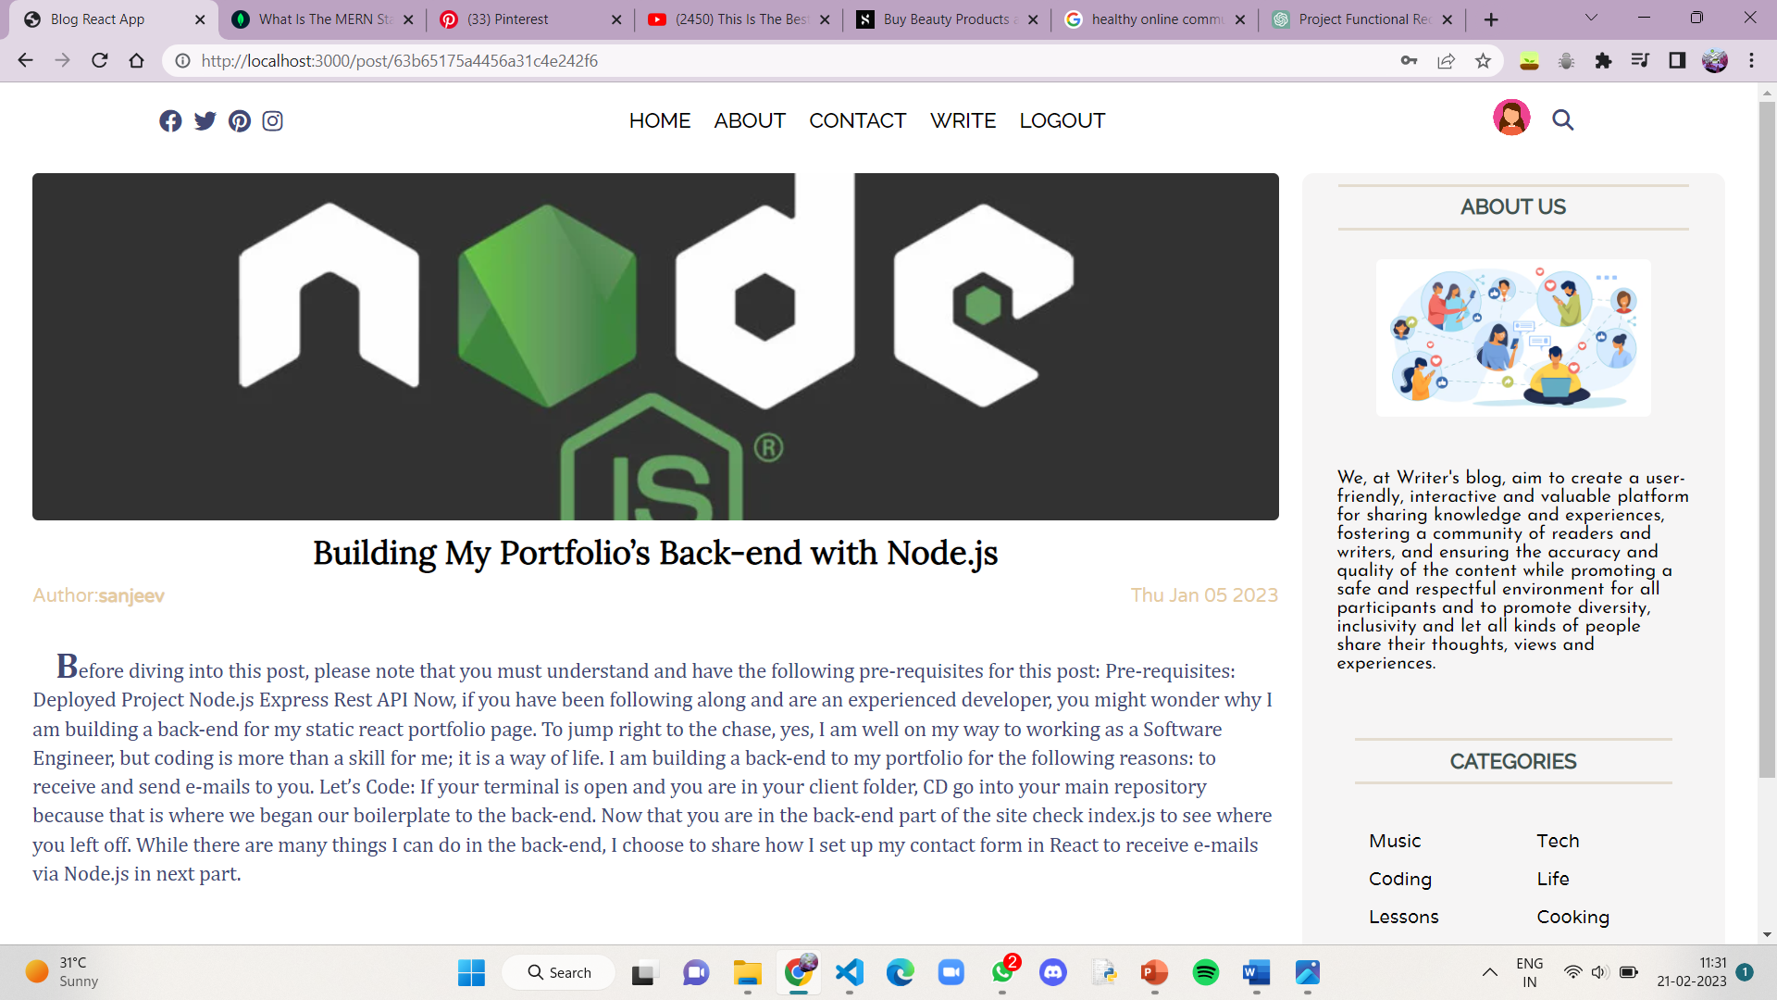

**Fig.24 Post page**

When you click on the name of the author of a particular blog, you will be directed to a page that contains all the blogs written by that particular author. It is shown below:

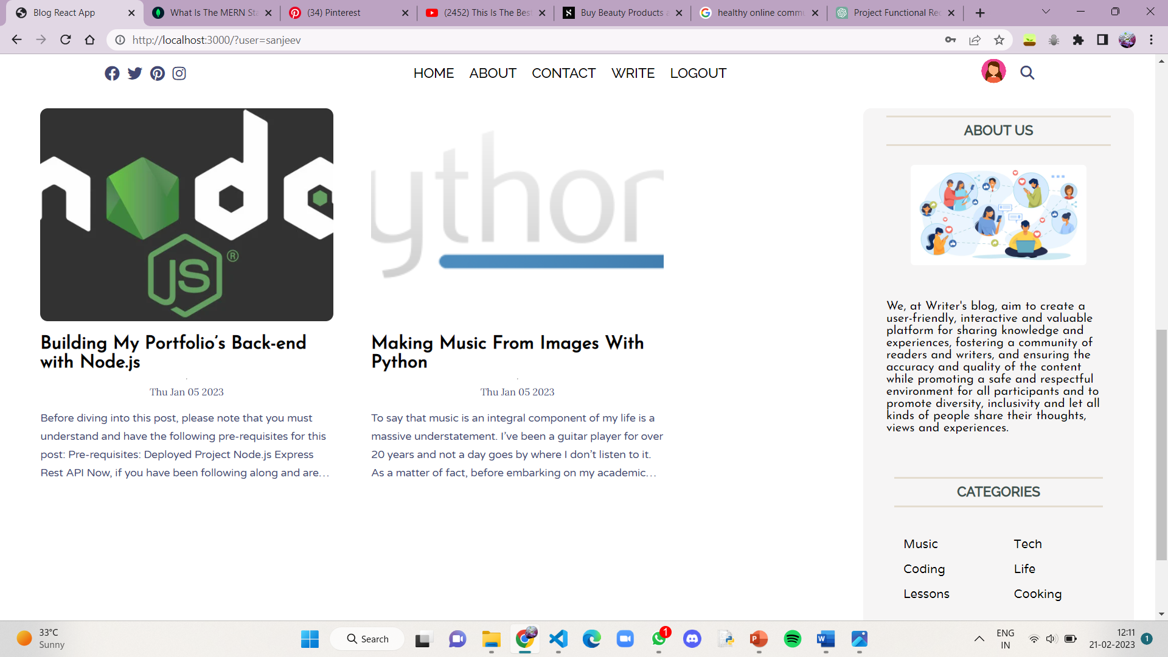

**Fig.25 Posts of an author**

An author when writes a blog can edit or delete his own blog. It is shown below:

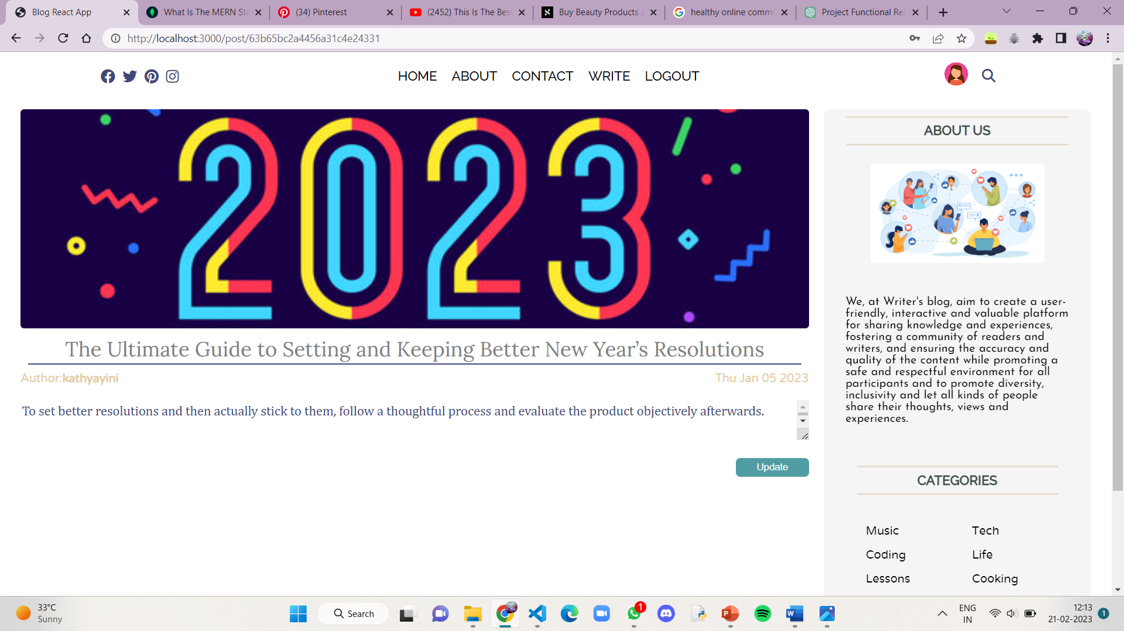

**Fig.26 Editing/Deleting a blog**

The settings or profile page of a user looks like this:

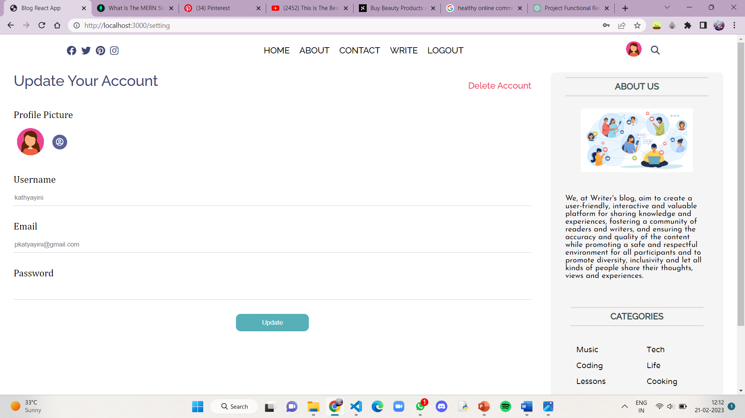

**Fig.27 Settings page**

1. **CONCLUSION**

In conclusion, a well-designed and well-implemented blog website can provide a valuable platform for sharing ideas, opinions, and information with a broad audience. A successful blog website requires careful planning and attention to both functional and non-functional requirements, including aspects such as performance, security, usability, and maintainability. By adhering to best practices and utilizing appropriate technologies and strategies, a blog website can be an effective tool for building an online community, engaging with readers, and promoting discussion and learning. However, it is important to continually monitor and update the website to keep it up-to-date and relevant, and to be responsive to user feedback and changing needs.

In addition to the technical considerations for a blog website, there are also other important factors to keep in mind. One key aspect is content creation and curation. A successful blog website requires high-quality, engaging content that resonates with the target audience. This content can take many forms, such as articles, videos, podcasts, or interactive media, and should be regularly updated to maintain reader interest.

Another important consideration is audience engagement. A blog website should be designed to encourage reader interaction, through features such as comments, social media integration, and email newsletters. Engaging with readers and responding to their feedback can help build a sense of community and increase loyalty to the website.

Finally, a successful blog website should be built with a clear purpose in mind. Whether the goal is to inform, educate, entertain, or persuade, the website should be designed with this purpose in mind and should strive to deliver on this goal consistently. By focusing on these key factors, a blog website can be a powerful tool for building a personal brand, promoting a cause, or sharing ideas and information with the world.

**BIBLIOGRAPHY**